**Scenario**

Several users have asked to use their personal iOS, Android, and Windows devices to access Contoso cloud resources. Since Contoso does not own the devices, you do not want to have the users perform an Azure AD join for full device management. Instead, you need to ensure that users are able to register their devices with Azure AD, which still allows you to apply company policy to apps as needed, and still permit users to access Contoso resources. You will test out Azure AD device registration using a Windows 11 device.

**Task 1:**

Create a support ticket, using the template provided, documenting planned activity and required resources. Determine what key indicators you will be monitoring.

File attached

**Task 2: Configure Azure AD device registration**

1. On **SEA-SVR1**, if necessary, sign in as **Contoso\Administrator** with the password of **Pa55w.rd** and close **Server Manager**.
2. On the taskbar select **Microsoft Edge**, in the address bar type [**https://entra.microsoft.com**](https://entra.microsoft.com/), and then press **Enter**.
3. Sign in as user Admin@yourtenant.onmicrosoft.com, and use the tenant Admin password. If the **Stay signed in?** prompt appears, select **No**.

The Microsoft Entra admin center opens.

1. In the Microsoft Entra admin center, in the navigation pane, expand **Identity.**
2. Select **Devices** > **All devices**.

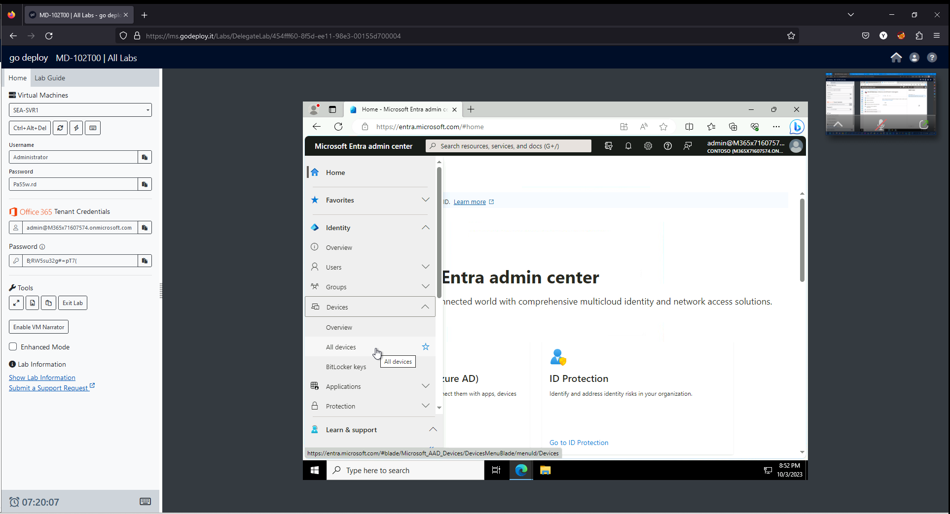

1. On the **Devices | All devices** page, select **Device settings**.
2. On the **Devices|Device settings** page, in the details pane, verify that **Users may register their devices with Azure AD** is set to **All** and is greyed out.

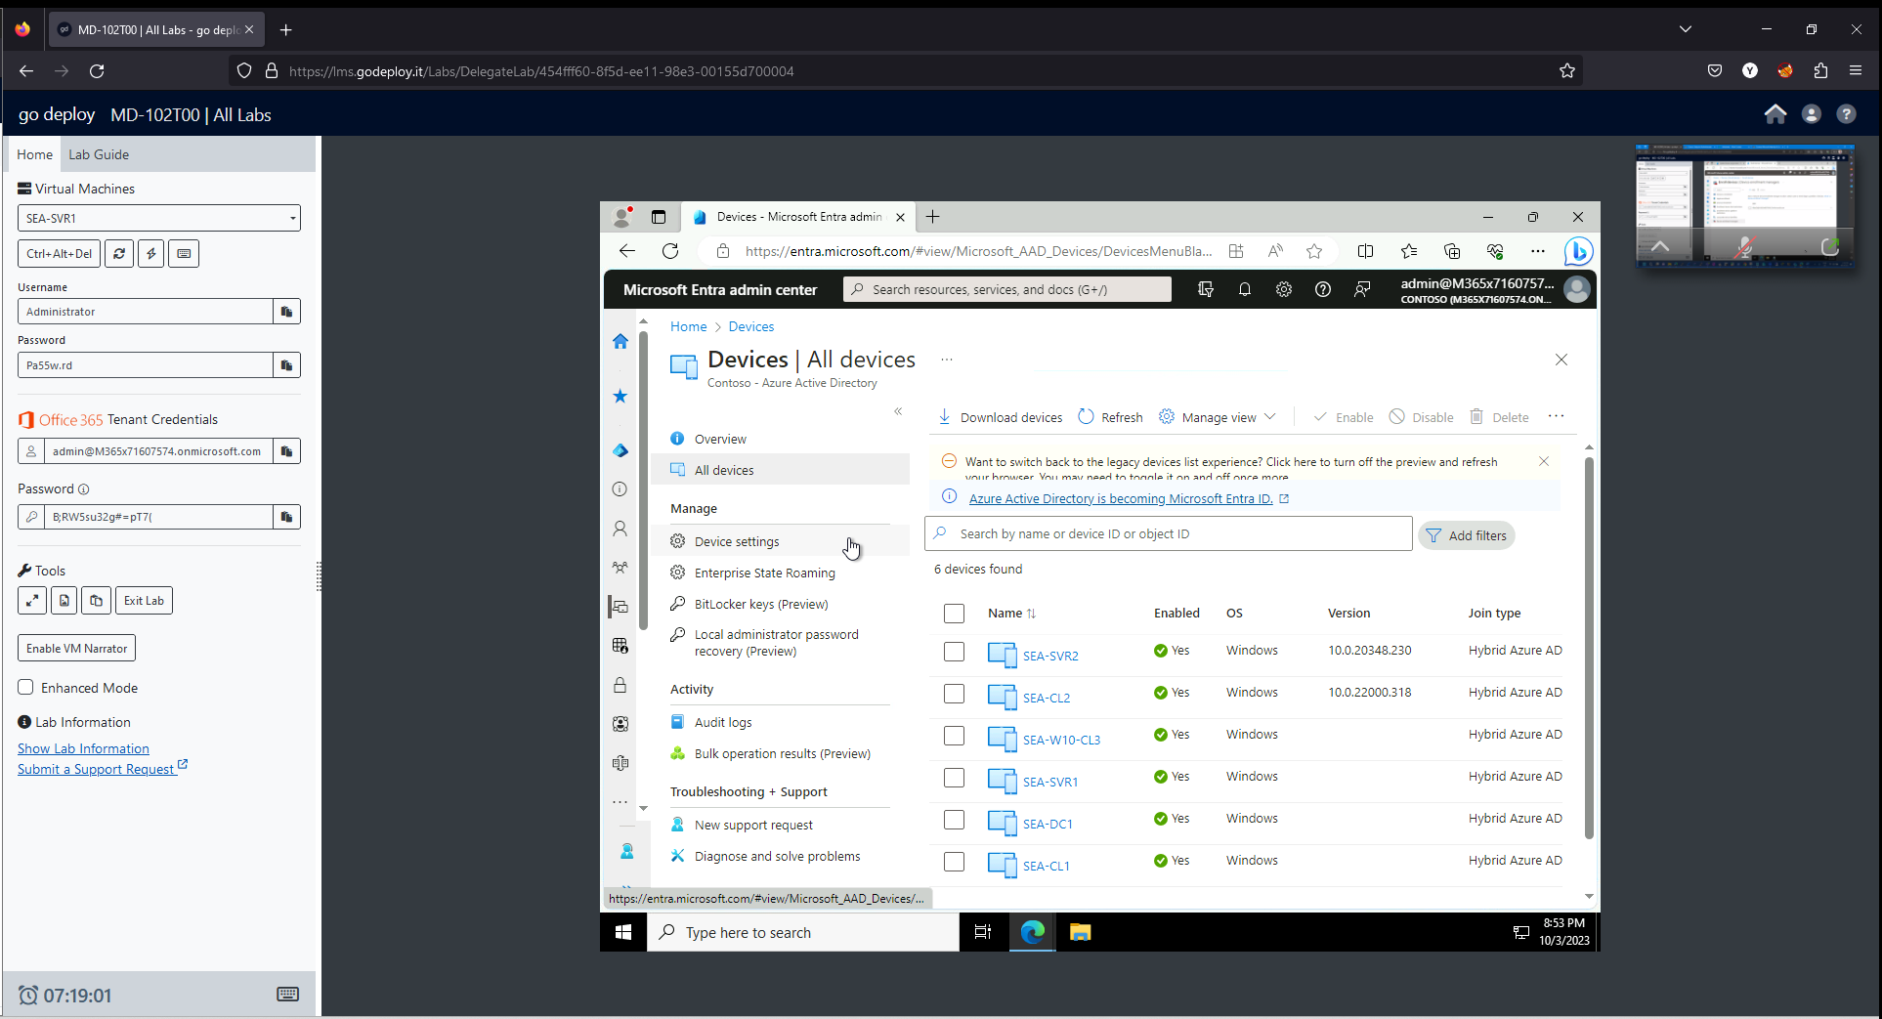

This option is greyed out and set to **All** by default when Microsoft Intune is enable in the tenant. This ensures that all users are able to register Windows 10 or newer personal, iOS, Android, and macOS devices with Azure AD.

**Task 3: Perform Azure AD registration**

1. Switch to **SEA-WS1** and sign in as **Admin** with the password of **Pa55w.rd**.
2. On the taskbar, select **Start** and then select **Settings**.

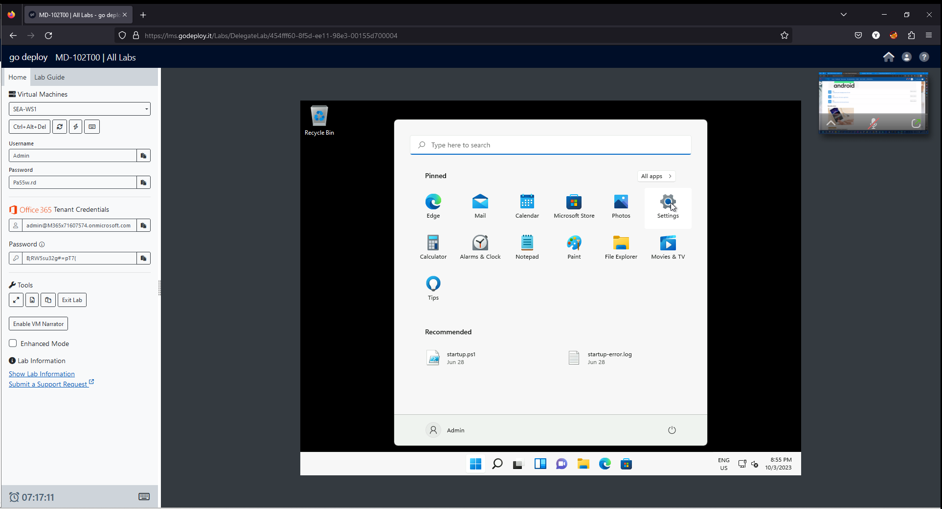

1. In the **Settings** window, select **Accounts**.

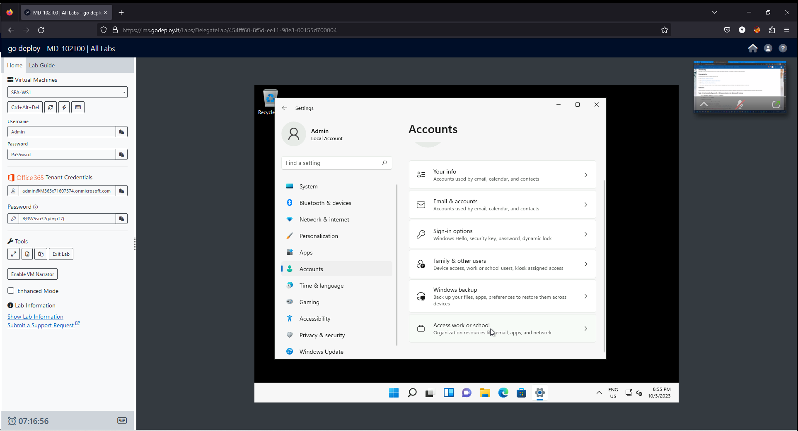

1. On the Accounts page, select **Access work or school**.
2. In the **Access work or school** page, select **Connect**.

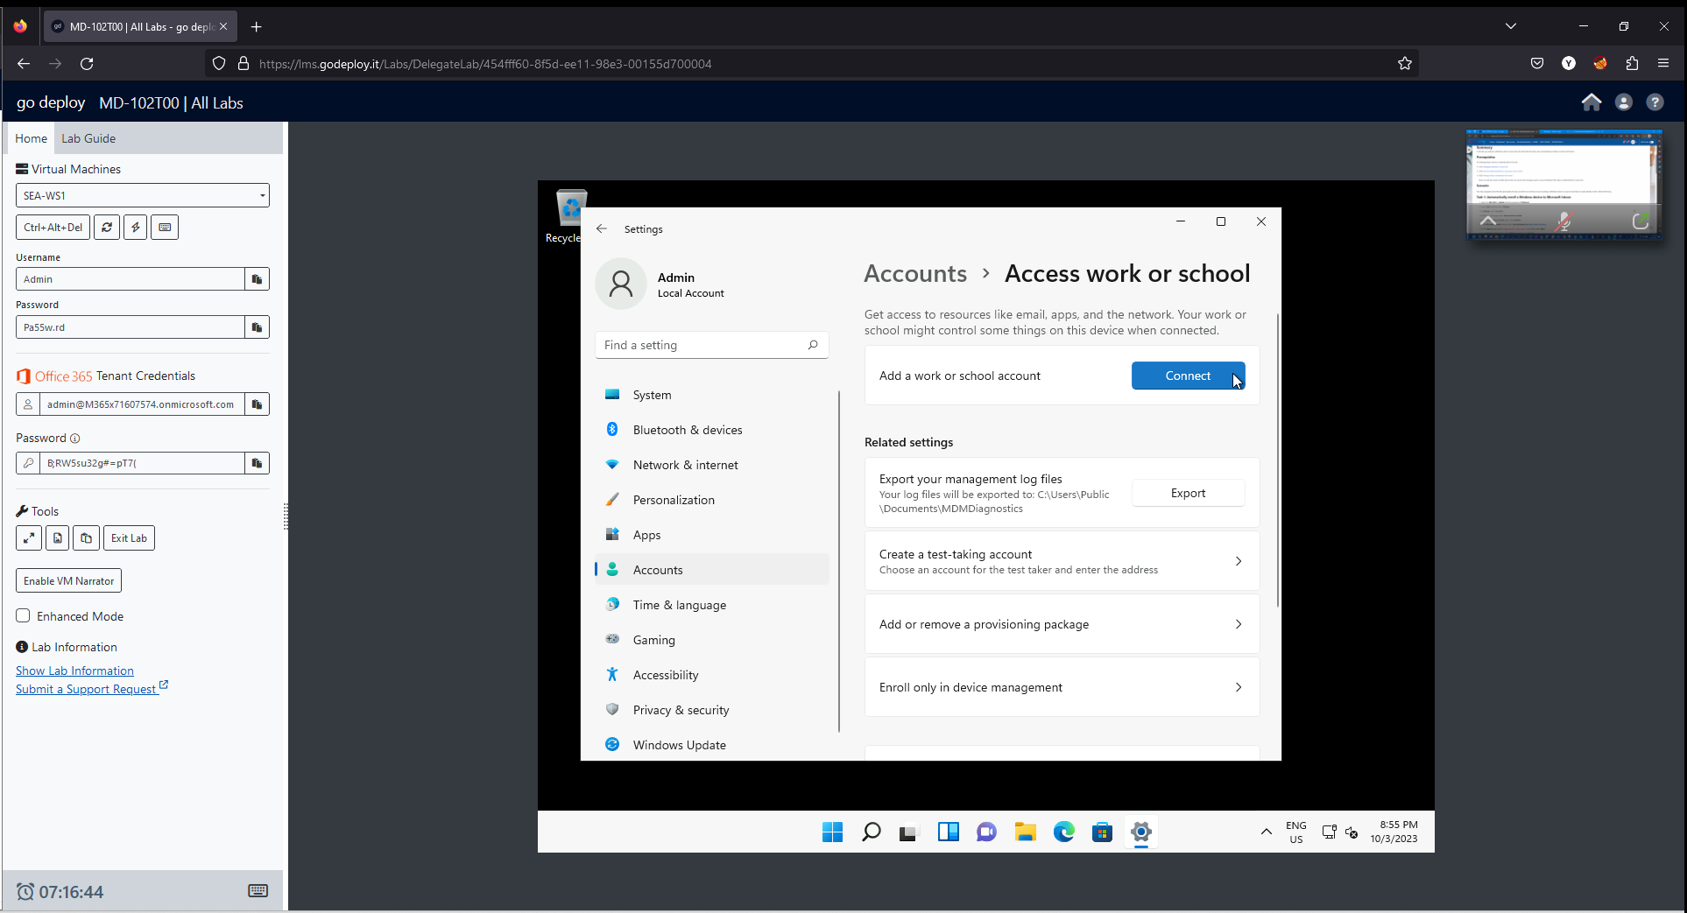

1. In the **Microsoft account** window, in the Email address box, enter JoniS@yourtenant.onmicrosoft.com and then select **Next**.

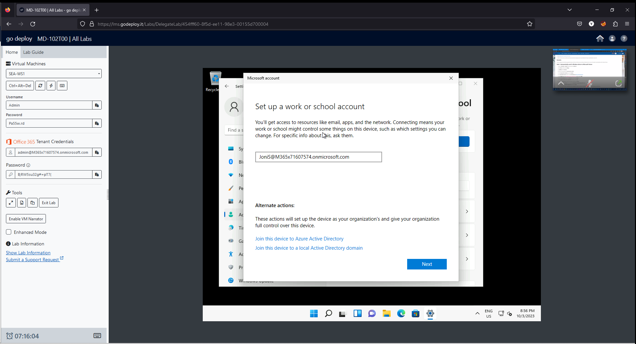

1. On the **Enter password** page, enter the tenant password provided by your instructor and then select **Sign in**.

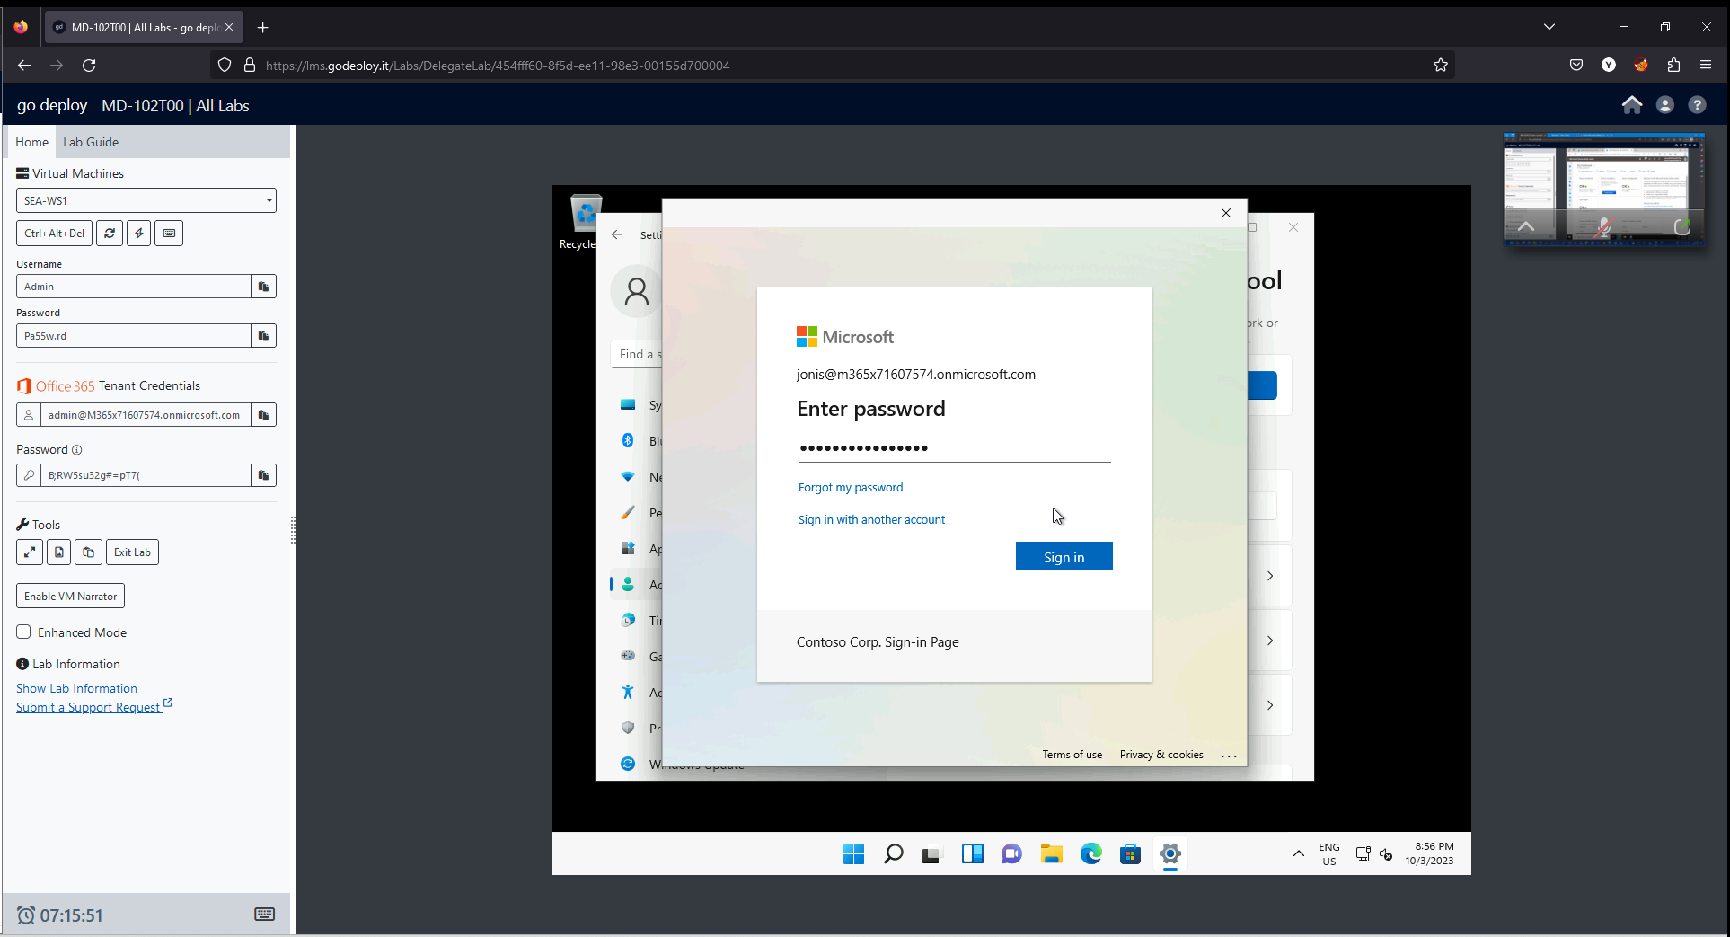

1. On the **You're all set!** page, select **Done**.

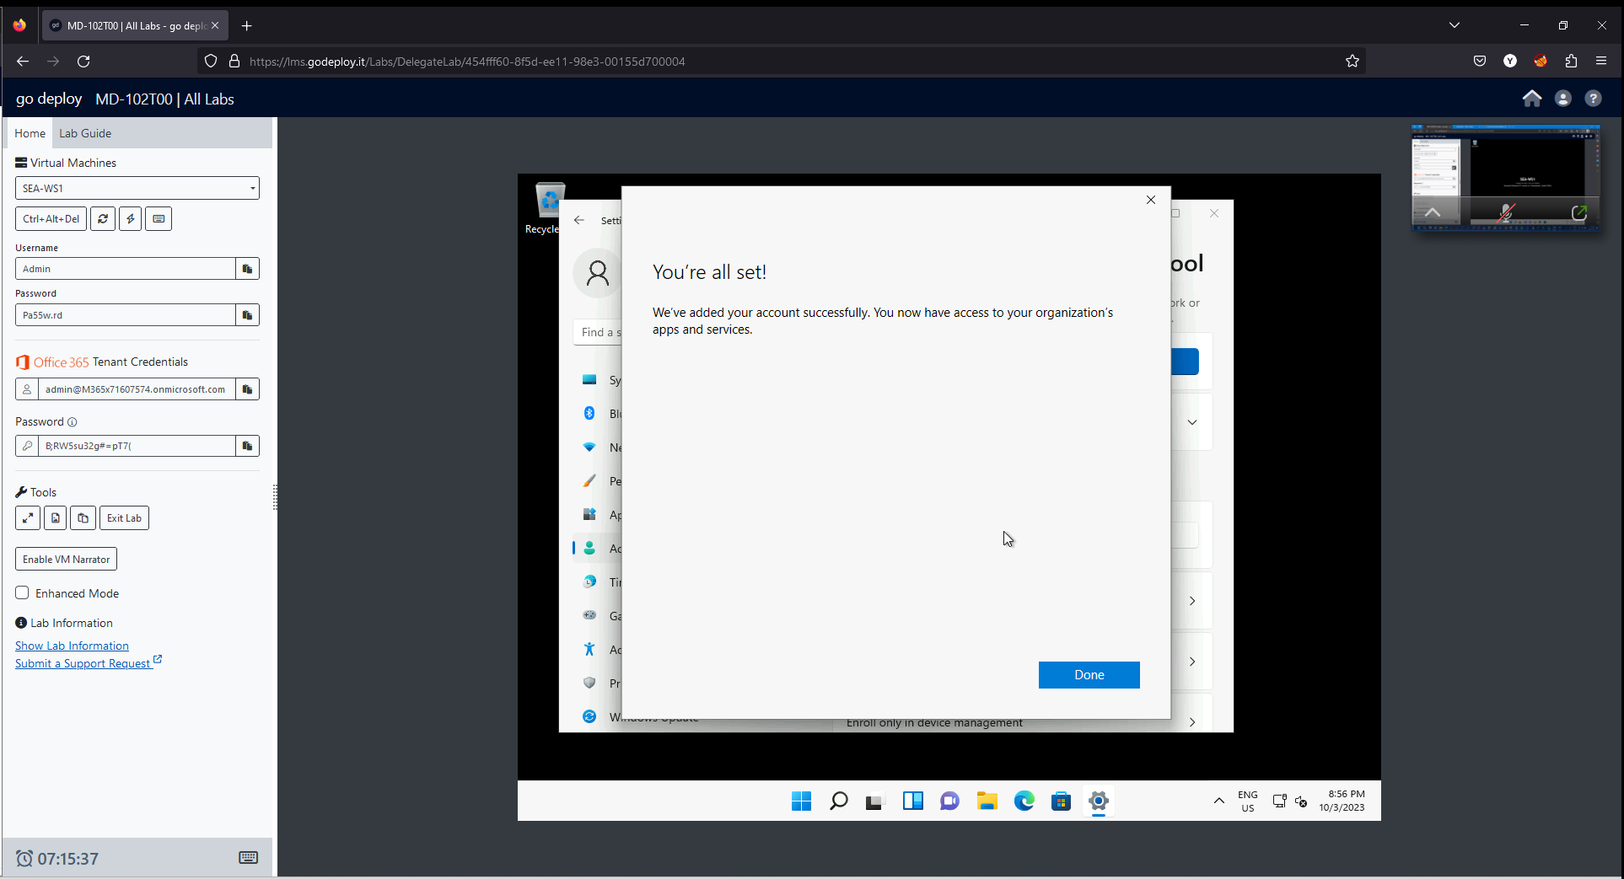

1. On the **Access work or school** page, verify that Joni's Work or school account is displayed.
2. Close the **Settings** page.

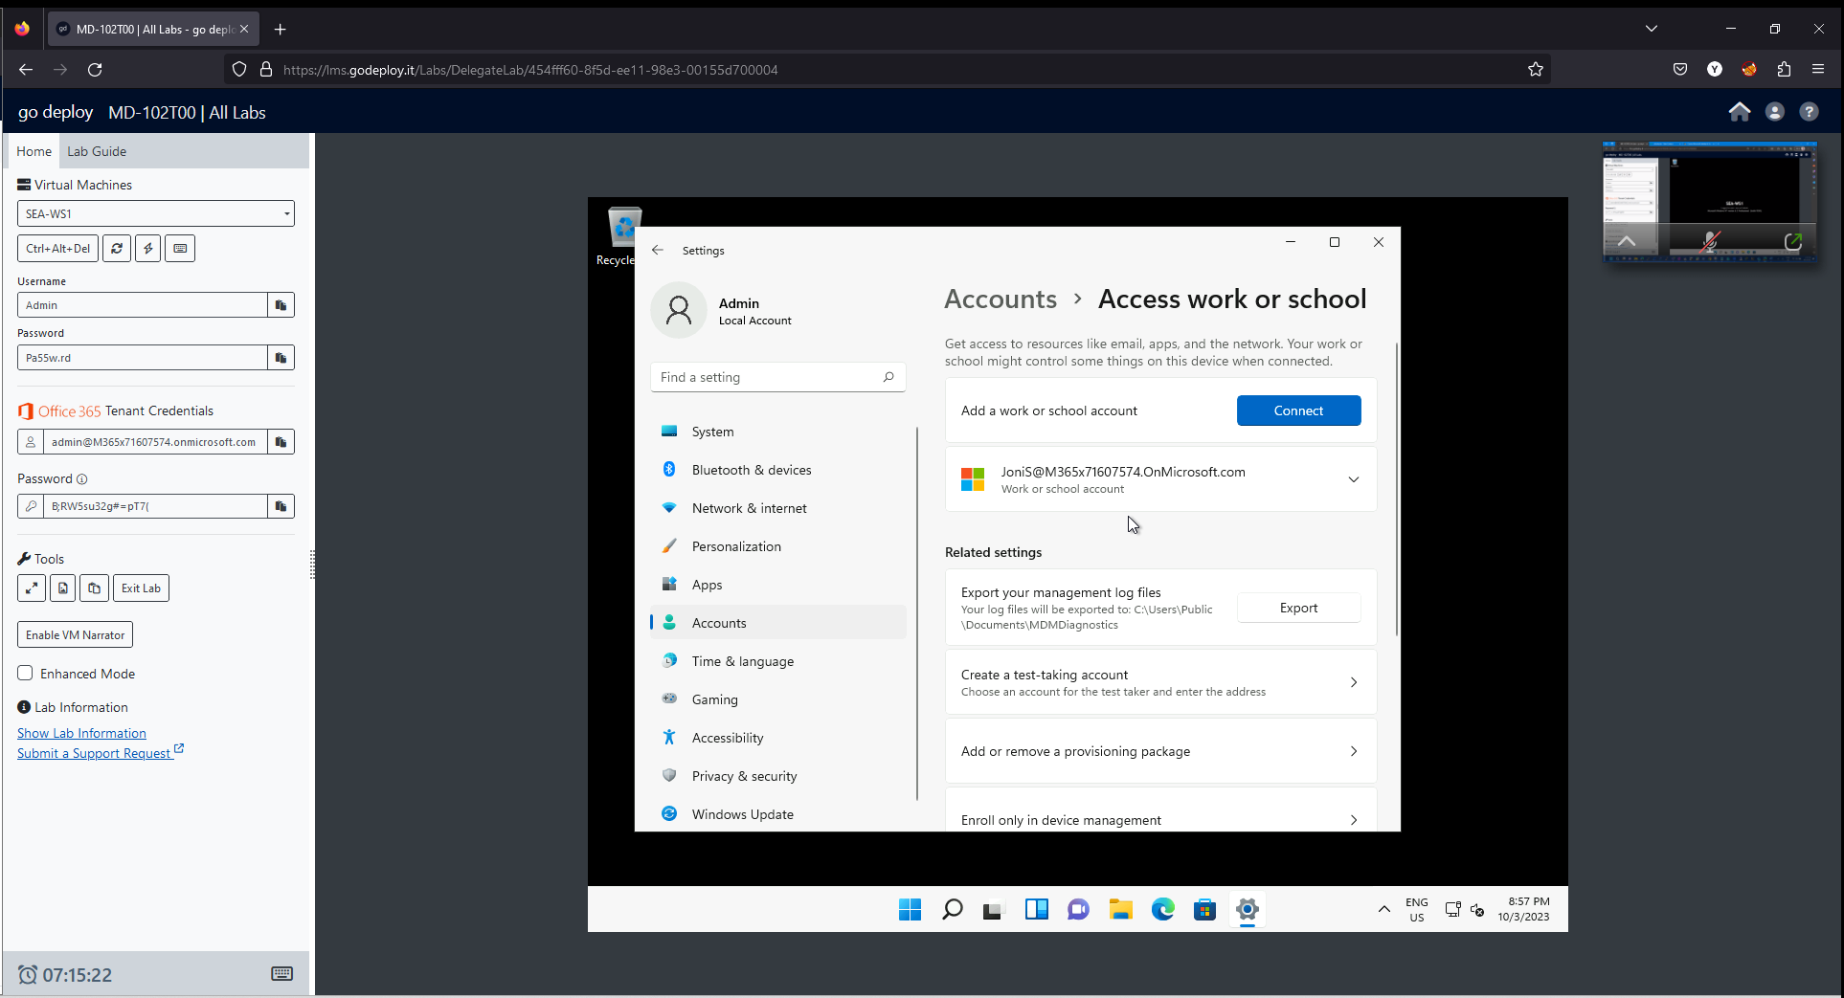

**Task 4: Validate Azure AD registration**

1. On SEA-WS1, right-click **Start**, and then select **Windows Terminal (Admin)**. At the User Account Control, select **Yes**.
2. In the PowerShell console, type the following and press **Enter**:

dsregcmd /status

1. In the output under **User State**, verify that **WorkplaceJoined : YES** is displayed. This indicates that the user has performed a device registration in Azure AD.

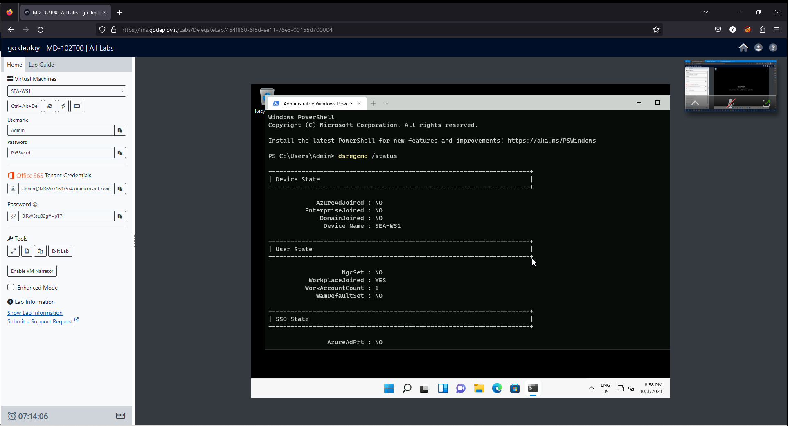

1. Close PowerShell and then sign out of SEA-WS1.
2. Switch to **SEA-SVR1**.
3. In Microsoft Edge, in the Microsoft Entra admin center, expand **Identity.**
4. Select **Devices**, then select **All devices**. In the Devices pane, notice that SEA-WS1 is listed.

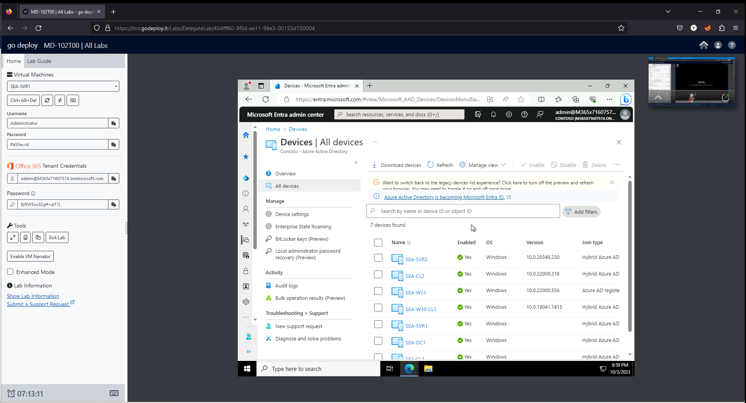

1. Verify that the **Join Type** is listed as **Azure AD registered** and that the owner is **Joni Sherman**.

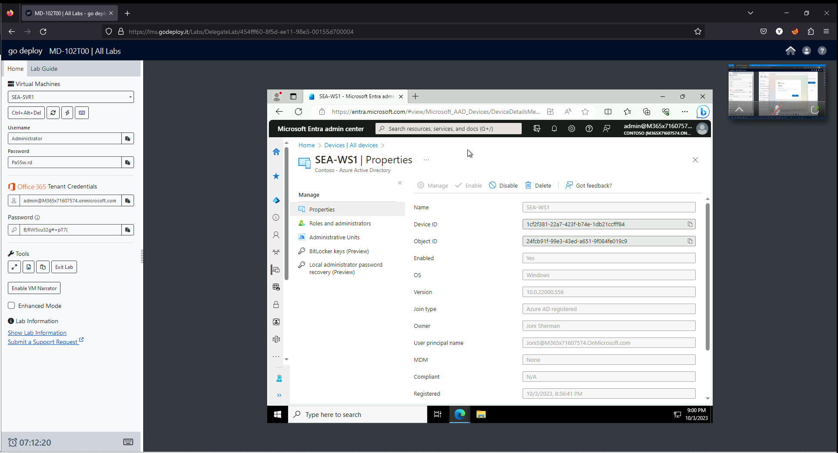

Notice that the device is Azure AD registered, NOT Azure AD joined. Azure AD registered devices are typically devices that cannot be Azure AD joined, or devices that are personally owned by the user. Registering a device will provide access to Cloud based resources.

1. Close Microsoft Edge.

**Task 5: Sign in to Windows and disconnect from the organization**

1. Switch to **SEA-WS1** and attempt to sign in as [JoniS@yourtenant.onmicrosoft.com](mailto:JoniS@yourtenant.onmicrosoft.com).

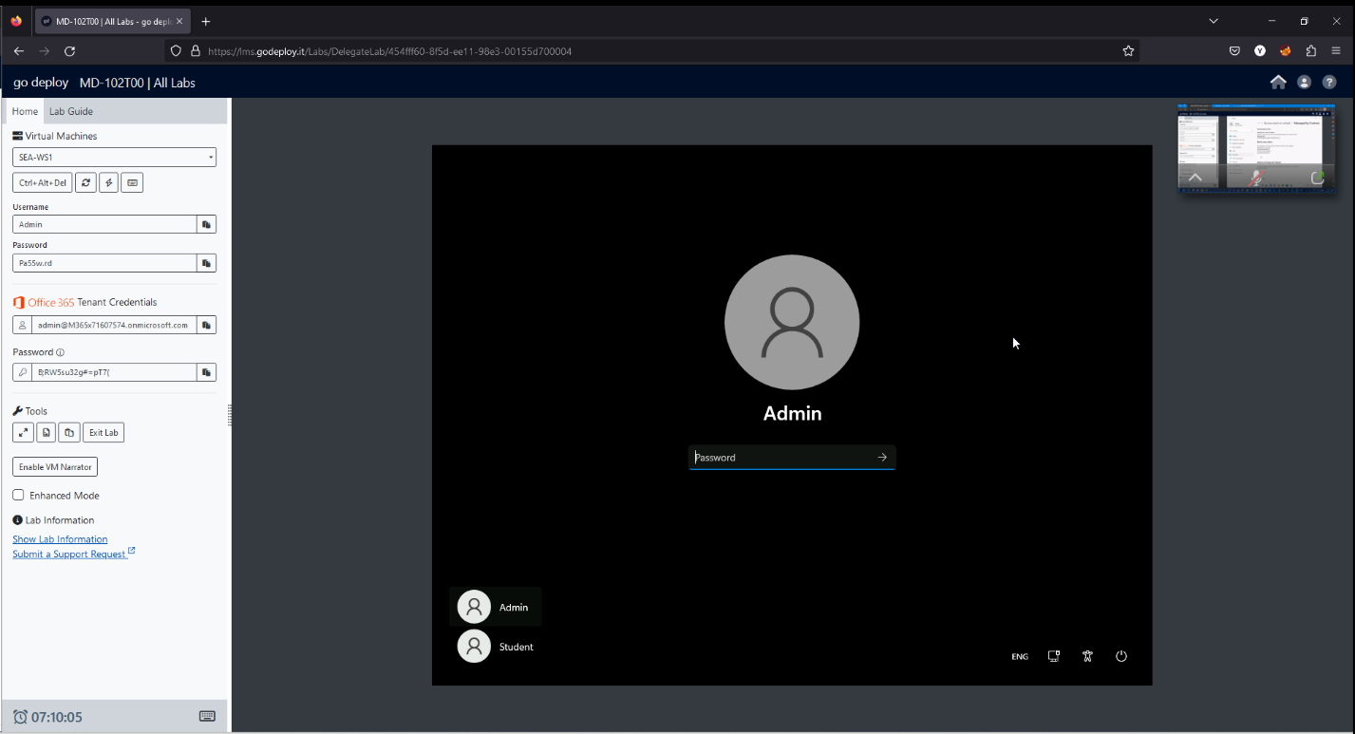

Notice that unlike Azure AD Joined devices, an Azure AD registered device does not allow a user to sign in to the device with an Azure AD credential.

1. On SEA-WS1, sign in as **Admin** with the password of **Pa55w.rd**.
2. Select **Start** and then select **Settings**.
3. In the **Settings** window, select **Accounts**.
4. On the Accounts page, select **Access work or school**.
5. In the **Access work or school** page, select the **JoniS** Work or School account.

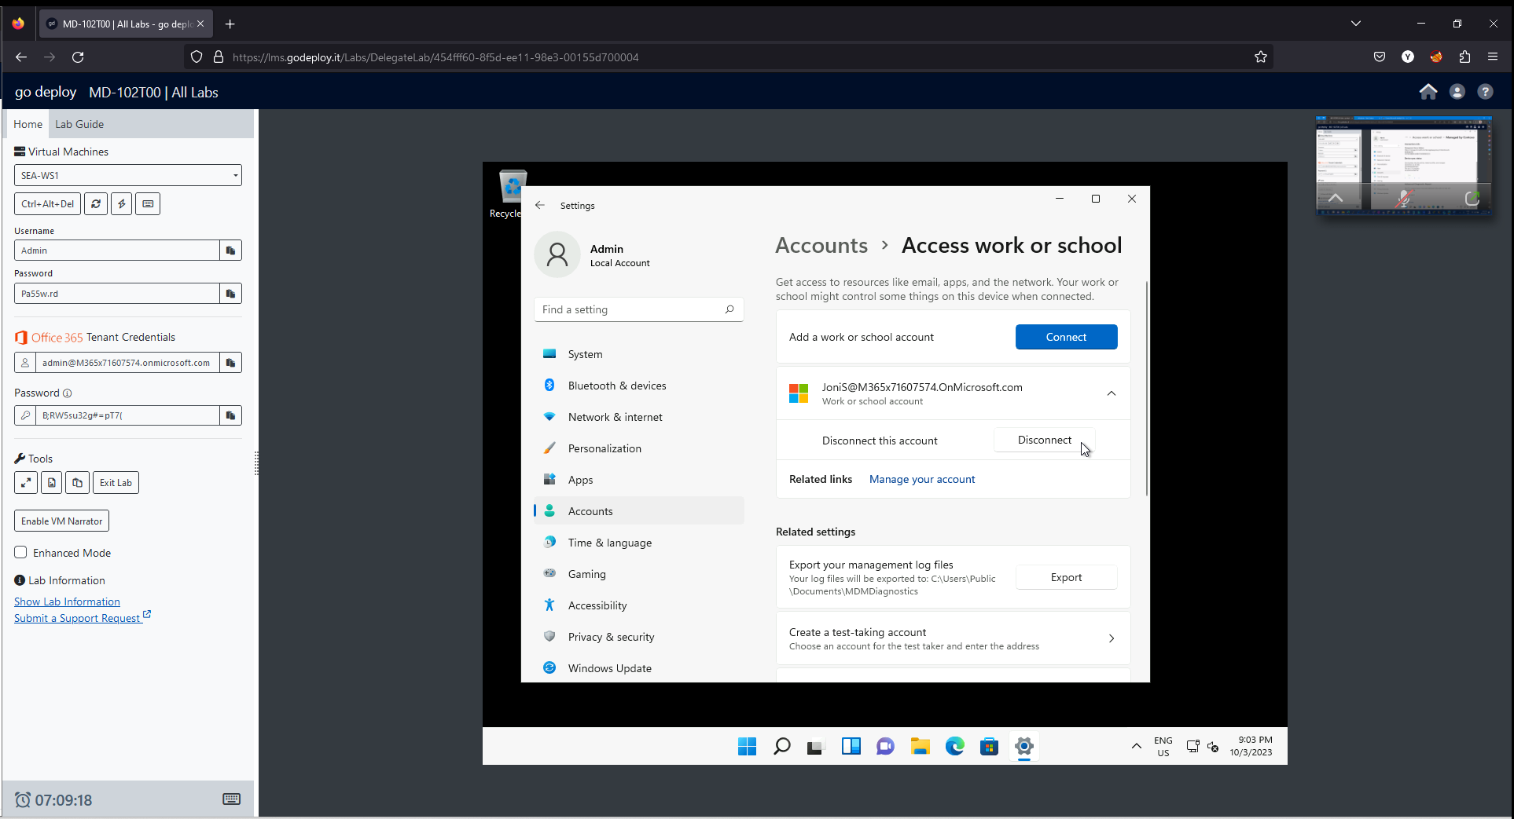

1. Next to Disconnect this account, select **Disconnect** and then select **Yes**.

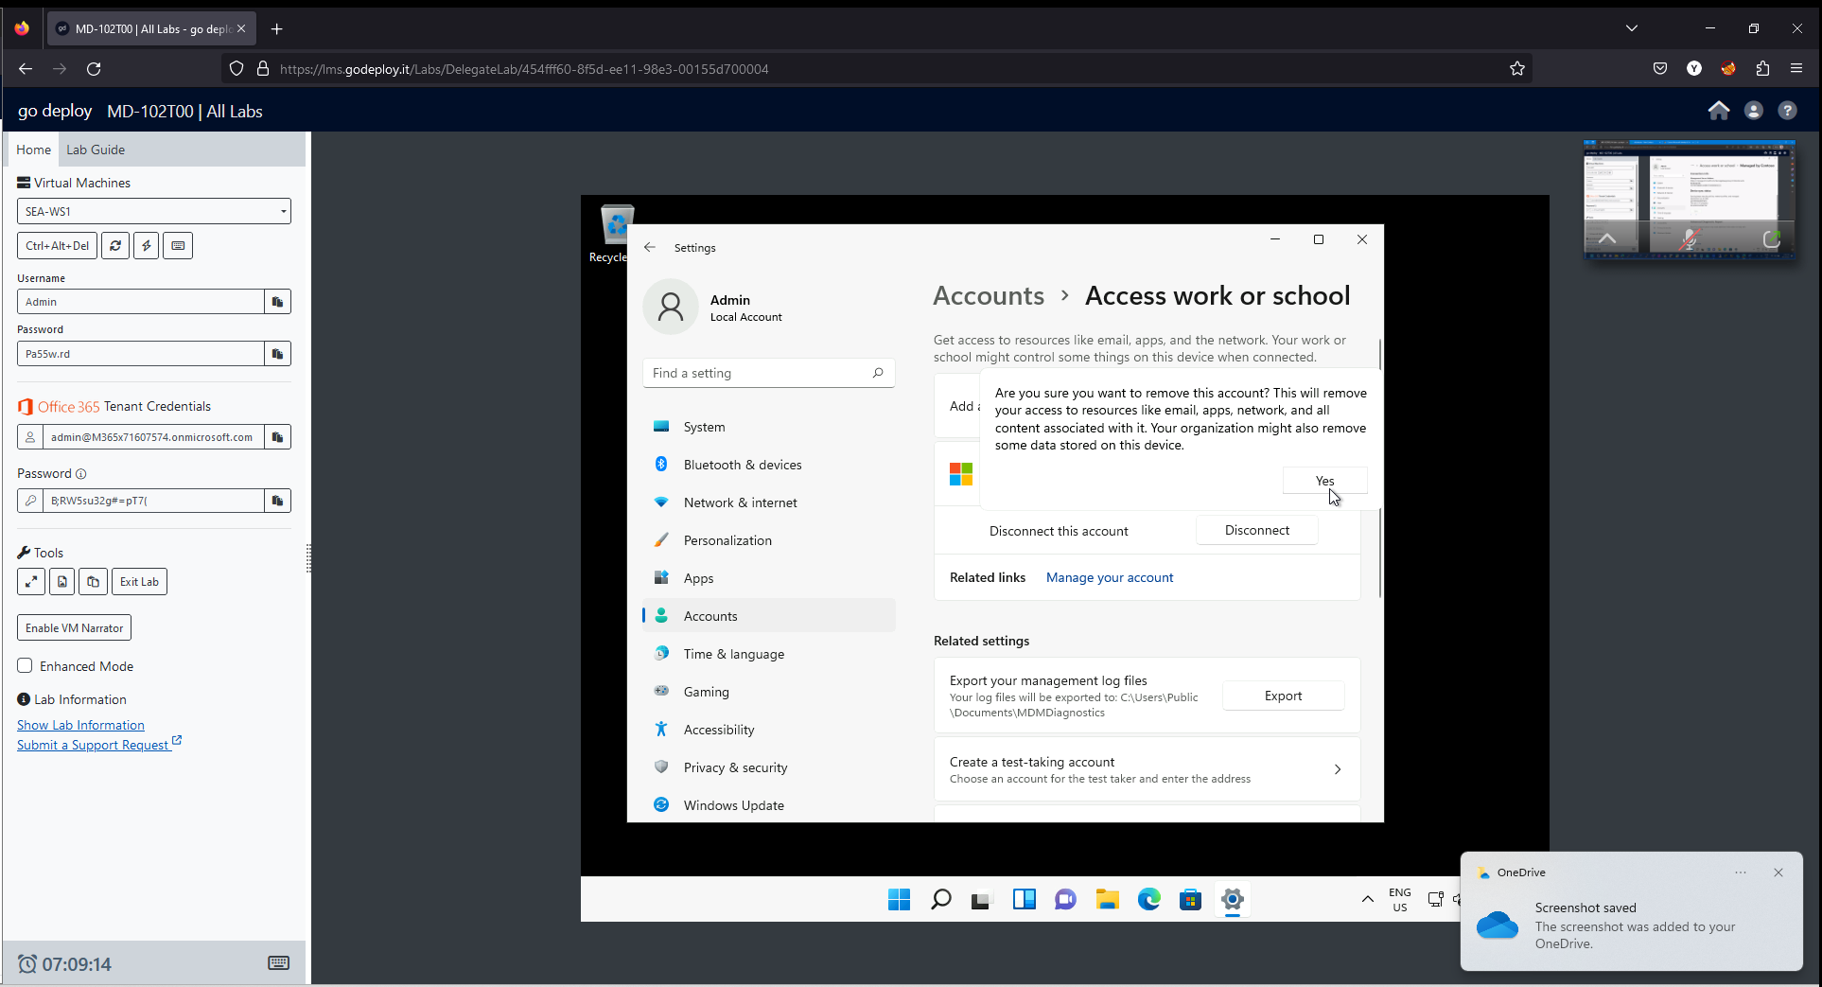

Notice that you do not have to restart to disconnect a registered device from Azure AD.

1. Sign out of SEA-WS1.

**Results**: After completing this exercise, you will have configured Azure AD device registration.

**Task 6:**

Document findings from the lab activity in the support ticket. Include any changes to the system that occurred. Document whether any anomalies were observed during the maintenance/monitoring.

File attached

**Task 7:**

Send an email to your manager with results of your testing and recommendations for production.

